1) ORACLE Installation

2) Yield-Man installation

3) License activation + service mode

4) GexDB schema creation

- edit <Yield-Man installation path>/install/oracle/gexdb_oracle_install.ini
GexDataBaseInstance
- open DOS prompt
- cd <Yield-Man installation path>/install/oracle
- execute gexdb_oracle_install.bat
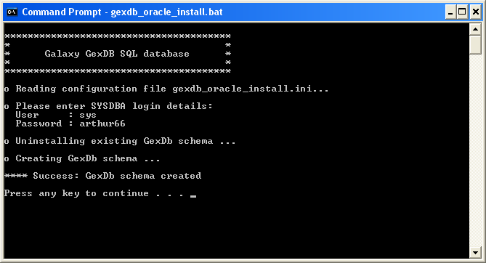

5) Examinator Production installation

6) Yield-Man configuration

- Options: Database Options->Locations + Save
- Create Oracle DB link
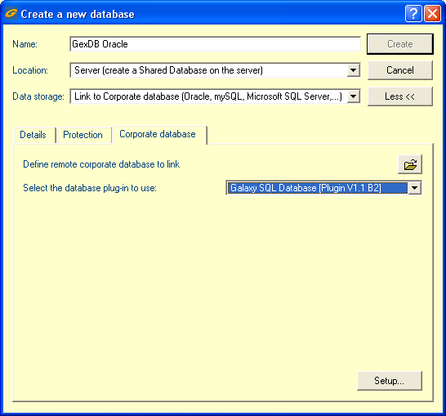
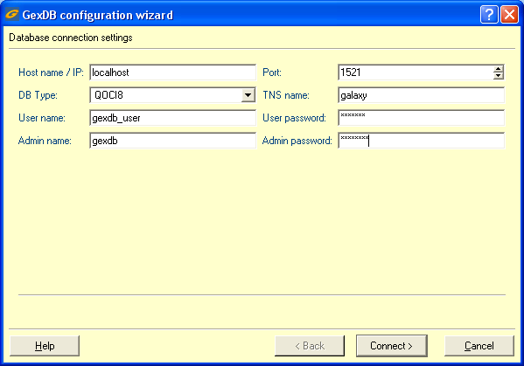
- 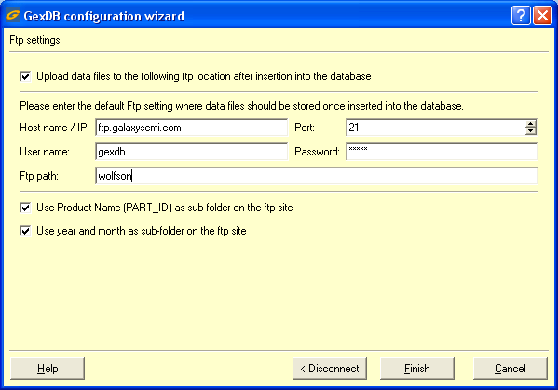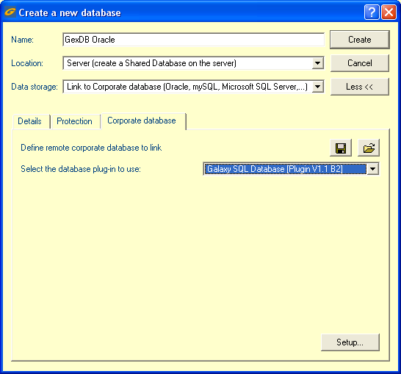
- Intranet WebSite
- config.gexdbkeys files
- DataPumps

